ICDControl – מערכת לניהול הודעות ומבנים
Ben Zacai 207978545 , Yam Elgabsi 208698266
ציון: 95
Activity Diagram
1. Message/Record Addition Process
This diagram details the flow for adding a new message or structured record to the database, including validation and permission checks. Notably, it now includes the path for handling errors returned from the Database Server.
- Client Workstation: The process starts with an Initial state, moving to Add Message and then Fill Message Details. A decision point, Input Valid?, checks the data.
  - If No, an Error Message is displayed, and the flow loops back to Add Message.
  - If Yes, the request is sent to the Backend Server.
- Backend Server: The server Receives Request and performs a Check User Permission. The Has Permission? decision follows:
  - If No, an Access Denied message is sent back to the Client Workstation, which then loops back to Add Message.
  - If Yes, the flow proceeds to the Database Server.
- Database Server: The process Insert New Struct Record is attempted. A decision point, Query Executed Successfully?, checks the outcome.
  - If Yes, the server confirms Return Success, and concludes with a Final state.
  - If No (an error occurs), the server returns an Error message to the Backend Server.
- Error Handling (Backend & Client): When the Backend Server receives a Return Error from the Database Server, it proceeds to Process The Error and sends an Access Denied (or appropriate error) message back to the Client Workstation, which then loops back to Add Message.
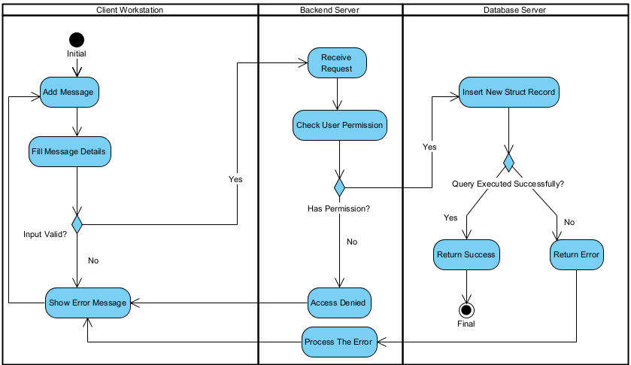

2. Login and Authentication Process
This diagram outlines the user login sequence, including credential validation, password hashing, and role retrieval.
Client Workstation
The process Starts with the User enters Email/ID and Password on the Login Screen.
- An Input validation (empty)? check is performed.
  - If Yes (a field is empty), the flow loops back to the input step.
  - If No, the flow proceeds to check the Empty field? decision point.
    - If Yes (this second check seems redundant in the diagram but directs to a different path), the process flows to Show error message, then loops back to the input step.
    - If No (no empty fields), it Sends credentials to the Backend.
- If authentication is successful (indicated by a return flow from the Backend), the process Opens the Main Window (with appropriate Admin/User buttons enabled) and reaches the Final state.

Backend Server
The server Receive login request.
- It Query Database for the user's password hash.
- The Backend then Hashes the input password and compares it with the stored Hash.
  - If Hashes match? is Yes, it retrieves the UserRole and sends it back to the Client.
  - If No, it executes Return error to the Client.
- If the database returns an error (from a failed query), the Backend will Process the error, and then execute Return error to the Client.

Database Server
The server Receive Query for the password hash. The User found? decision determines the response:
- If No, it flows to Return 0 User not found. The process then returns this to the Backend Server.
- If Yes, it flows to Return Hash to the Backend for comparison.
- A query failing for other reasons (not explicitly shown as a decision but implied by the flow from Receive Query to Process the error on the Backend) will also result in a return flow to the Backend's Process the error activity.
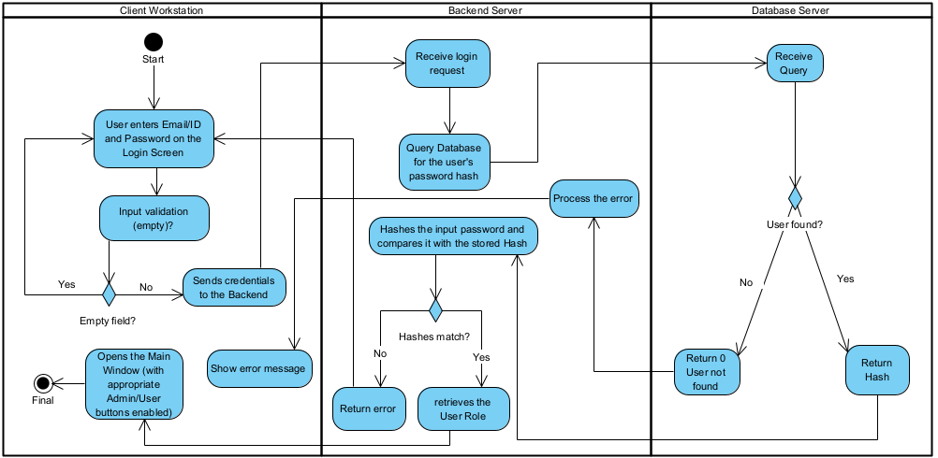

3. ICD Export Process
This diagram describes the steps required to export an Interface Control Document (ICD) structure as a .h (C header) file.
- Client Workstation: The process Starts with the User selects an ICD and clicks 'generate' (instead of 'Export to .h').
  - The client then Send ICD request to the Backend Server.
  - The client Receive generated string from the Backend Server.
  - Next, the user Choose File Path where to save the .h file.
  - The file is saved via Create and write to .h file.
  - The process concludes with a Final state.
- Backend Server: Upon receiving the request, the server Receive ICD Request and Query Database for the struct.
  - After receiving the data from the database, it Iterates through every field to generate the C code string and returns this string to the Client.
- Database Server: The server Receive Query and Return requested ICD data to the Backend Server.
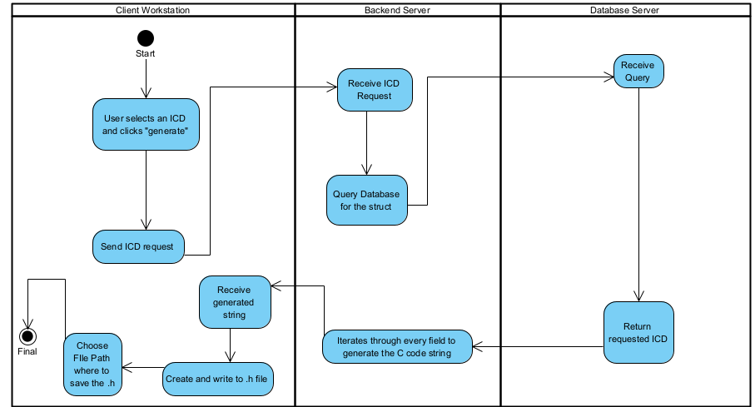

    - Class diagram that sequence diagrams based on:
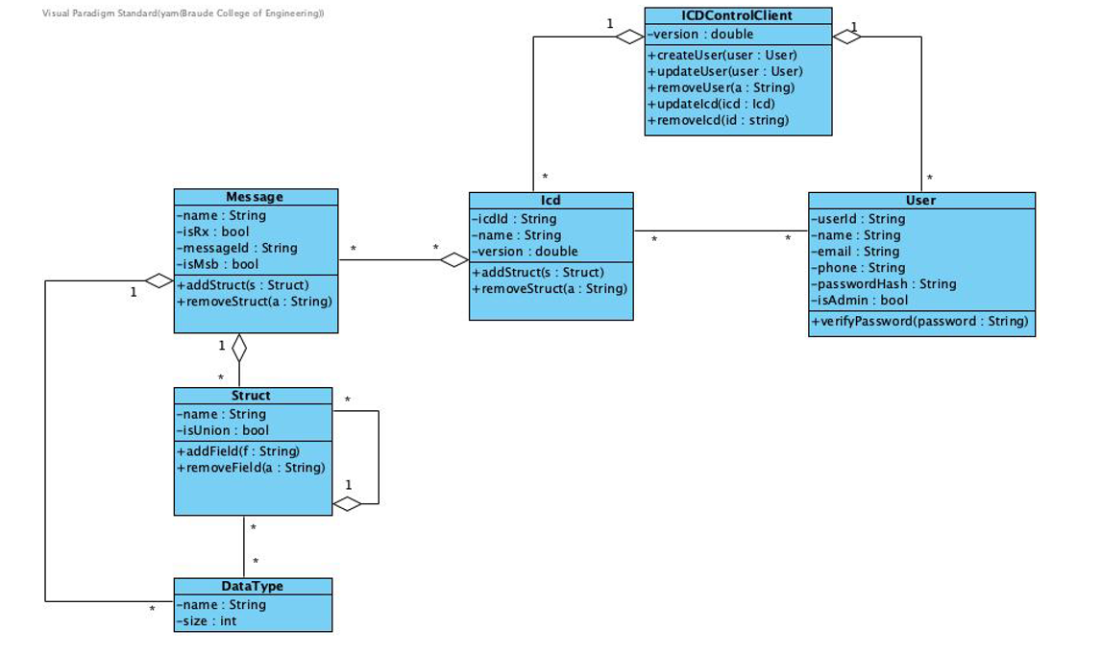
Sequence Diagrams:
1. Sequence Diagram – Message/Record Addition Process
This sequence diagram describes the full interaction between the user, the client application, the backend server, and the database when adding a new ICD message or structured record.
The process begins with the user selecting the “Add Message” option and filling in the required details. The client performs local validation on the input fields. If the data is invalid, an error message is shown and the user is redirected back to correct the input. If the data passes validation, the client sends the request to the backend.
The backend receives the request and performs a permission check to ensure the user is authorized to add or modify the selected ICD structure. If the user does not have the required permission, the backend returns an “Access Denied” response, which is presented to the user. If the user is authorized, the backend forwards the new record to the database manager.
The database manager inserts the new message/record into the SQL database. After the insertion succeeds, a success result travels back through the backend and the client, and the client notifies the user that the record was successfully added.
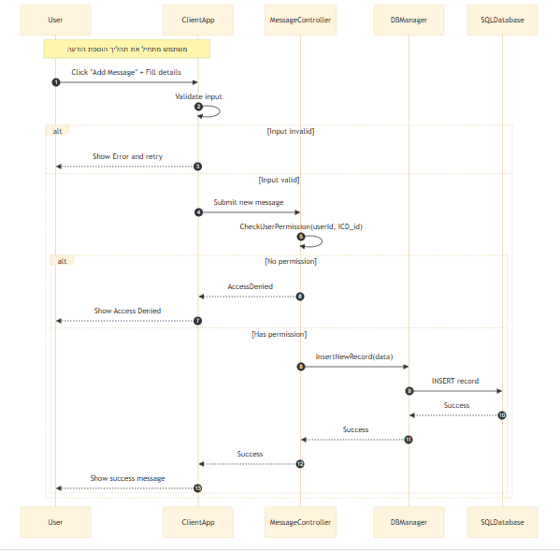

2. Sequence Diagram – Login and Authentication Process
This diagram illustrates the login process including field validation, credential verification, password hashing, and role retrieval.
The workflow begins when the user enters their email/ID and password. The client first checks for empty fields. If required inputs are missing, the client displays an error message and does not send the request to the backend. If the fields are valid, the login request is forwarded to the backends' authentication controller.
Upon receiving the request, the backend hashes the provided password to compare it securely with the stored hash. It sends a query to the database manager requesting the user’s stored password hash. The database checks whether the user exists:
- If the user does not exist, the backend returns a login-failure response.
- If the user exists, the stored hash is returned to the backend.
The backend compares the incoming hash with the stored one. If the hashes do not match, an authentication error is sent back to the client. If the hashes match, the backend then queries the database again to retrieve the user’s role (Administrator / Editor / Viewer). Once the role is received, the backend sends a successful login response along with the role information, and the client proceeds to open the main application window with the appropriate permissions enabled.

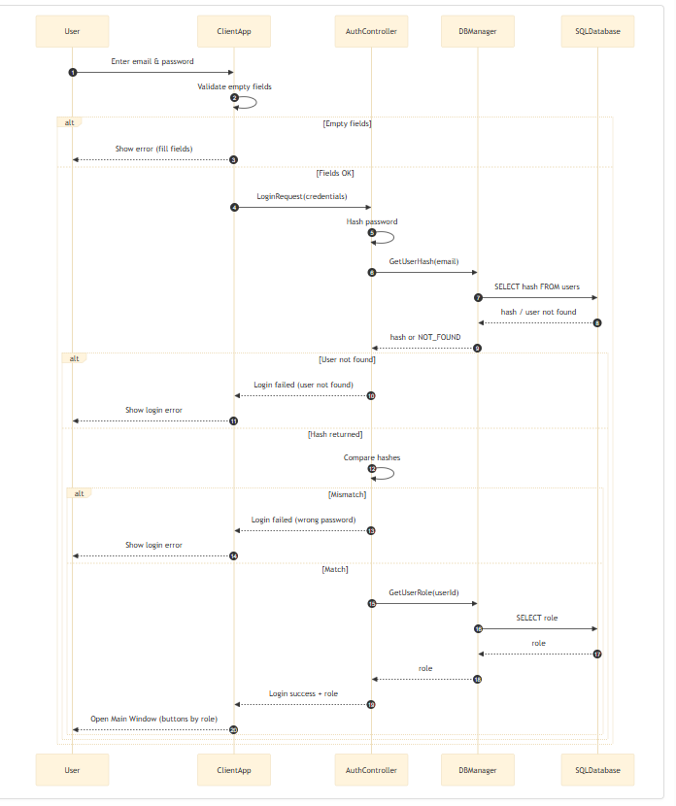
3. Sequence Diagram – ICD Export Process (.h File Generation)
This sequence diagram represents the export mechanism for generating a C header (.h) file from an ICD definition.
The process begins when the user selects an ICD from the list and clicks the “Export to .h” button. The client application prompts the user to choose a file path and then sends an export request to the backend.
The backend receives the request and contacts the database manager to retrieve the selected ICD structure. The database performs the corresponding SQL query and returns the stored JSON representation of the ICD record.
The backend then processes this ICD data: it parses the structure, iterates through the fields, and generates the formatted C-compatible header text representing the ICD message or structure. Once the header code is created, it is returned to the client application.
Finally, the client writes the generated text into a .h file at the user’s chosen location and shows confirmation that the export process has completed successfully.
